**Project Report IDS**

**Mohit Tiwari 17ucs092**

**Yash Agarwal 17dcs016**

**Akhil Sharma 17ucc009**

**Vishal Agrawal 17ucc068**

**Problem Statement:-**

Data Preprocessing and Preliminary Analysis and get inferences from the data.

**Data Sources:-**

<https://archive.ics.uci.edu/ml/datasets.php>

**Dataset description**

This is a Glass Identification Data Set from UCI. It contains 10 attributes including id. The response is glass type(discrete 7 values)

1. The study of the classification of types of glass was motivated by the criminological investigation. At the scene of the crime, the glass left can be used as evidence...if it is correctly identified!
2. Number of Instances: 214
3. Number of Attributes: 10 (including an Id#) plus the class attribute -- all attributes are continuously valued

**Goal:-**

The goal of the project is to find the type of glass based on the characteristics of the new glass. To perform preprocessing of the dataset provided for the glass type and get inferences from it Through Data analysis and Visualization Then Train Machine Learning Models/Algorithms.

**Importing Libraries**

**import pandas as pd**

**# read and wrangle dataframes**

**import matplotlib.pyplot as plt**

**# visualization**

**import seaborn as sns**

**# statistical visualizations and aesthetics**

**from sklearn.base import TransformerMixin**

**# To create new classes for transformations**

**from sklearn.preprocessing import (FunctionTransformer, StandardScaler)**

**# preprocessing**

**from sklearn.decomposition import PCA**

**# dimensionality reduction**

**from sklearn.discriminant_analysis import LinearDiscriminantAnalysis as LDA**

**from scipy.stats import boxcox**

**# data transform**

**from sklearn.model_selection import (train_test_split, KFold , StratifiedKFold, cross_val_score, GridSearchCV, learning_curve, validation_curve)**

**from sklearn.metrics import accuracy_score**

**from sklearn.neighbors import KNeighborsClassifier**

**from sklearn.tree import DecisionTreeClassifier**

**from sklearn.linear_model import LogisticRegression**

**from sklearn.svm import SVC**

**# model selection modules**

**from sklearn.pipeline import Pipeline # streaming pipelines**

**from sklearn.base import BaseEstimator, TransformerMixin**

**# To create a box-cox transformation class**

**from collections import Counter**

**import warnings**

**Importing Dataset**

**url = 'https://archive.ics.uci.edu/ml/machine-learning-databases/glass/glass.data'**

**data = pd.read_csv(url, header=None)**

**data.head()**

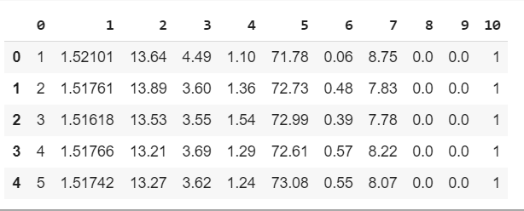

# **Exploring Dataset**

1.Count of Null values

2.Shape of dataset

3.Uniques values

*#Calculating number of null Values Belonging to each Column*

data.isnull().sum()

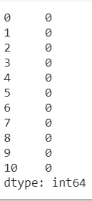

**#Shape of Data**

Data.shape

***The dataset consists of 214 observations***

data[10].unique()

**# Checking Data type of Columns**

**data.dtypes**

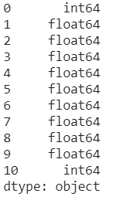

**#Counting Number of Values Belonging to each class**

data[10].value_counts()

sns.countplot(x=10, data=data)

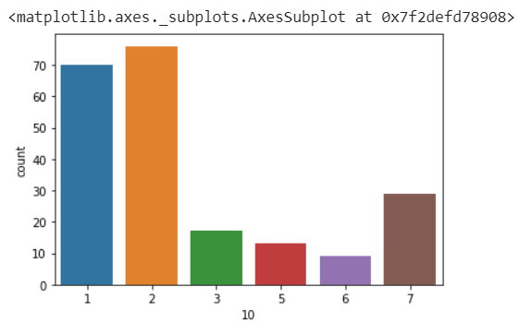

**As we can see The dataset is very very unbalanced.**

**The occurrences of types 1 and 2 constitute more than 67 % of the glass types.**

## **Preprocessing of the dataset:**

Data **preprocessing** is an integral step in Machine Learning as the quality of data and the useful information that can be derived from it directly affects the ability of our model to learn; therefore, it is extremely **important** that we **preprocess** our data before feeding it into our model.

**Attribute Information(Features)**:

Id number: 1 to 214 (removed from CSV file)

* RI: refractive index

* Na: Sodium (unit measurement: weight percent in corresponding oxide,

as attributes 4-10)

* Mg: Magnesium

* Al: Aluminum

* K: Potassium

* Ca: Calcium

* Ba: Barium

* Fe: Iron

* Type of glass: (class attribute) [1-7]

1. Building_windows_float_processed

2. Building_windows_non_float_processed

3. Vehicle_windows_float_processed

4. Vehicle_windows_non_float_processed

5. Containers

6. Tableware

7. Headlamps

# 

# **1. Adding meaningful column/attribute names**

**WHY?**

The columns in our dataset are named from 0 to 10 which is ambiguous and difficult to read and interpret.

names = ['Id','RI','Na','Mg','Al','Si','K','Ca','Ba','Fe','glass_type']

data.columns = names

data.head()

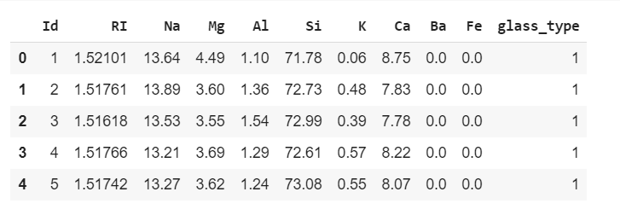

# **2.Removing unnecessary columns**

**WHY?**

Because our Dataset has columns which are not required and are not important.

data = data.drop('Id',1)

data.head(3)

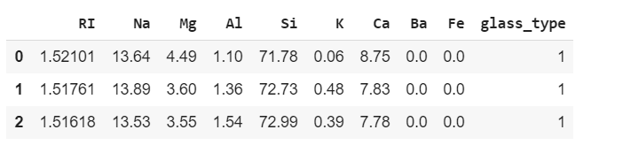

# **Statistics of Dataset**

## *Descriptive statistics*

Summarizing the distribution of the numerical variables.

data.describe()

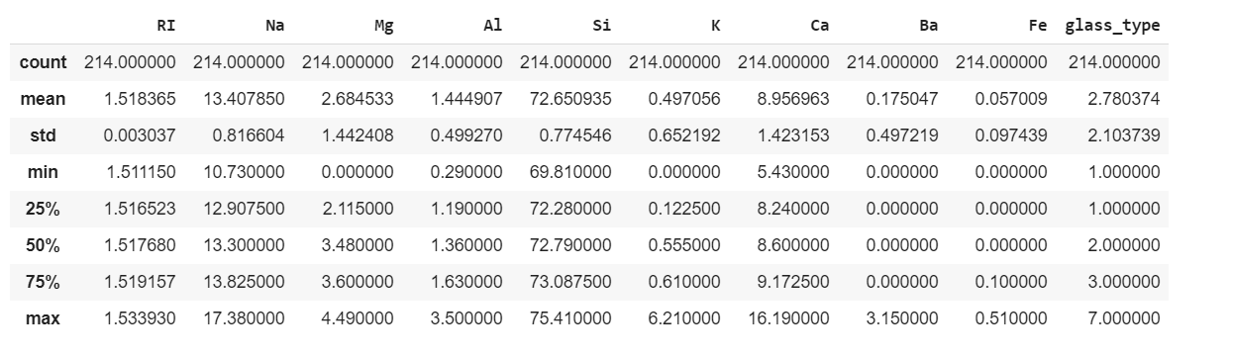

***OUTCOMES***

*Above statistics shows that data is across all attributes is not in the same range, so we will have to normalize the data first*

The features are not on the same scale. I.e. Si has a mean of 72.65 while Fe has a mean value of 0.057. Features should be on the same scale for algorithms such as logistic regression (gradient descent) to converge smoothly. Let's go ahead and check the distribution of the glass types.

# 

# **Data Visualization**

## *1. Using Univariate Plots*

**# Separating Class labels and Features**

features = ['RI','Na','Mg','Al','Si','K','Ca','Ba','Fe']

label = ['glass_type']

X = data[features]

y = data[label]

x2 = X.values

from matplotlib import pyplot as plt

import seaborn as sns

for i in range(1,9):

sns.distplot(x2[i])

plt.xlabel(features[i])

plt.show()

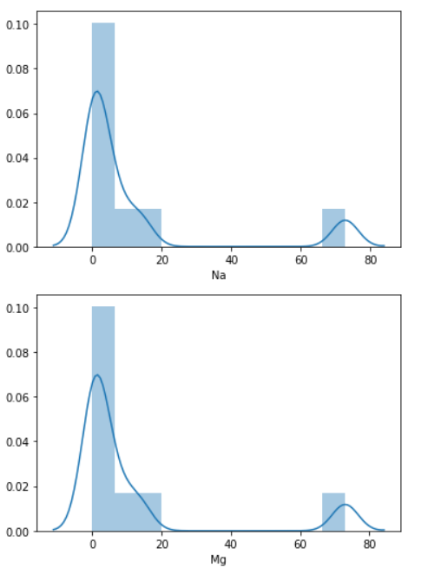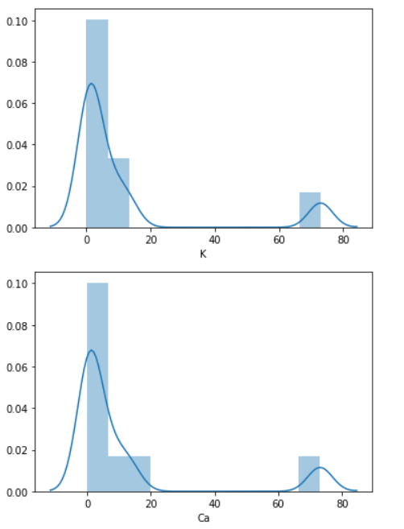

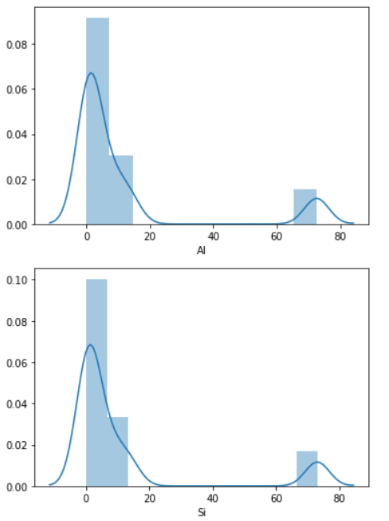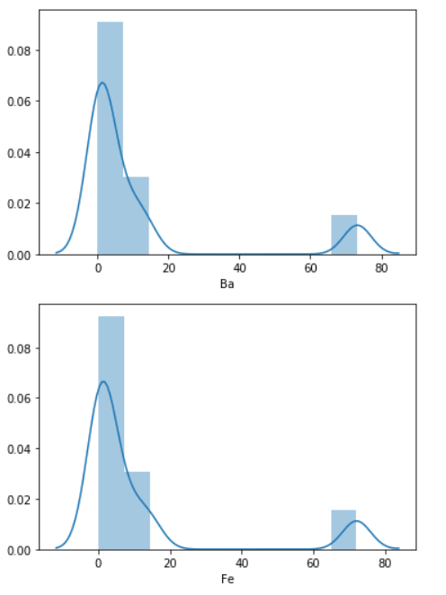

**Outcomes**

1. Our dataset is skewed either on the positive side or negative side and data is not normalized

**#Trying to gain more Insights about the data**

for feat in features:

skew = data[feat].skew()

sns.distplot(data[feat], kde= False, label='Skew = %.3f' %(skew), bins=30)

plt.legend(loc='best')

plt.show()

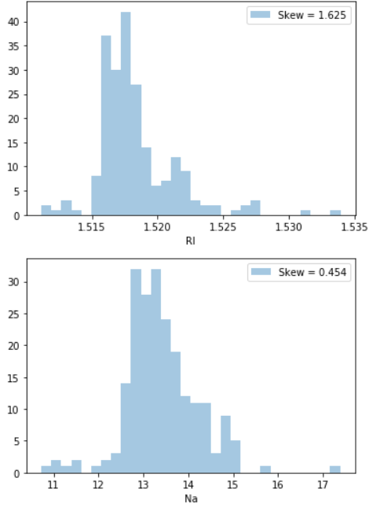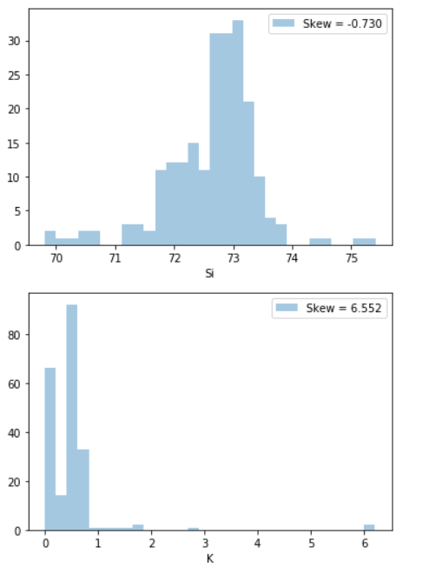

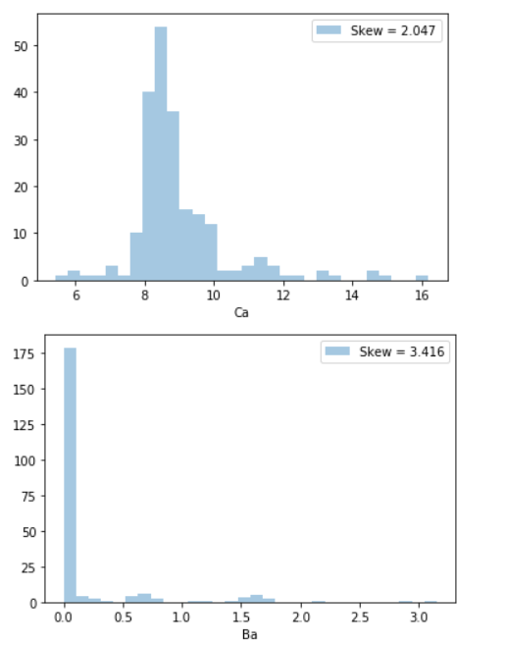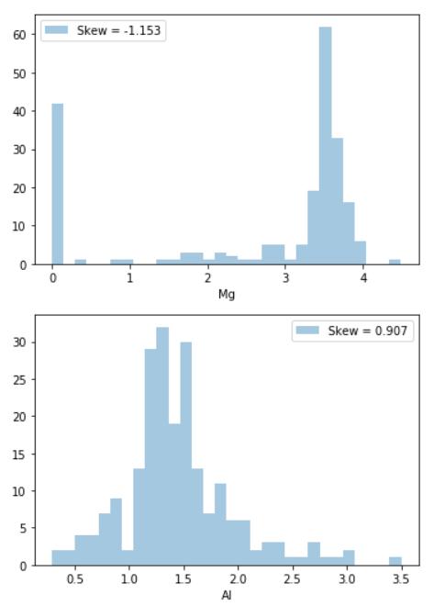

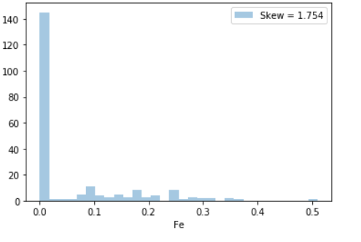

**Outcomes**

1. The distribution of potassium (K) and Barium (Ba) seem to contain many outliers.
2. The features Fe, Ba, Ca and K are Highly Skewed (They have High skew coefficients).
3. None of the features follow Normal Distribution (are not normally distributed).

## 

## 2. Using Multivariate Plots

x2 = pd.DataFrame(X)

plt.figure(figsize=(8,8))

sns.pairplot(data=x2)

plt.show()

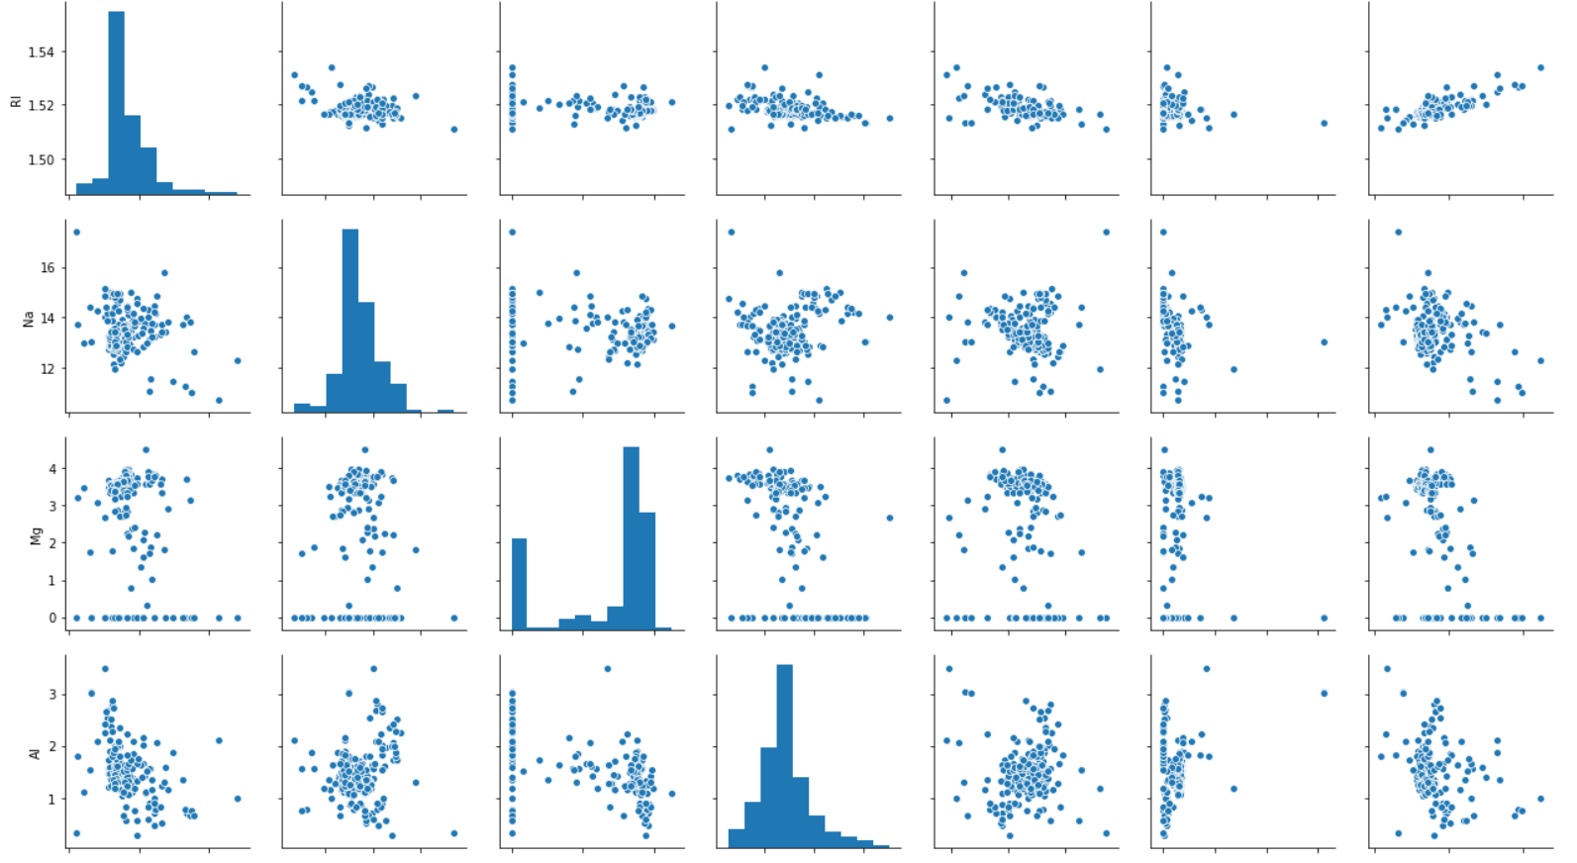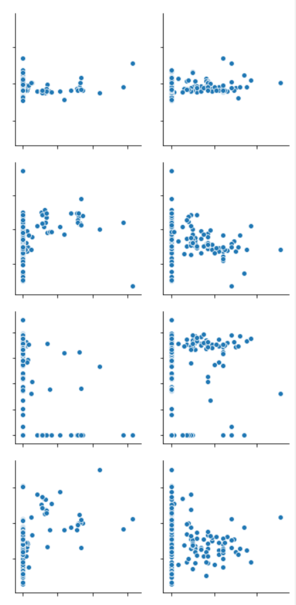

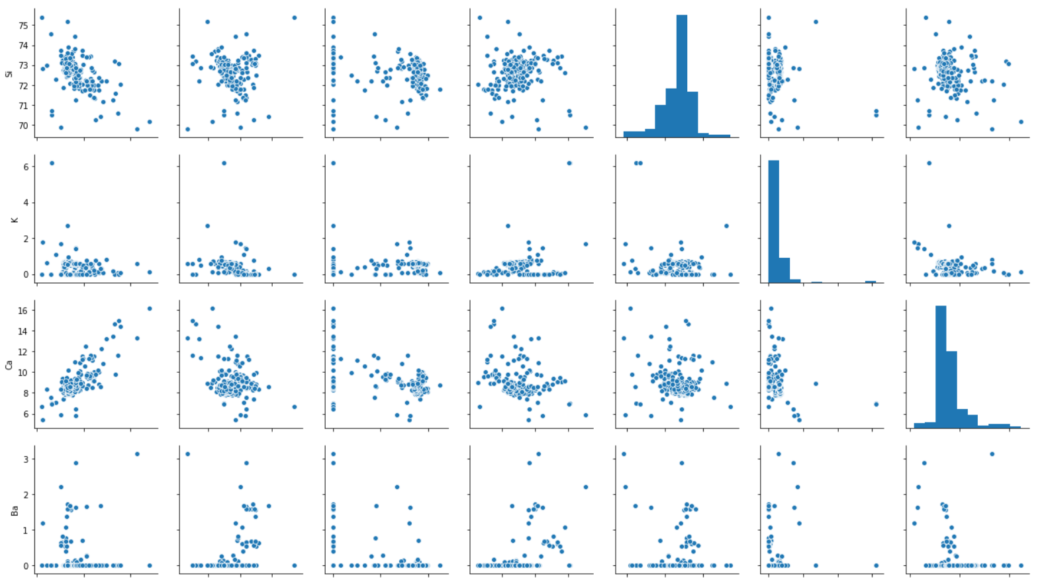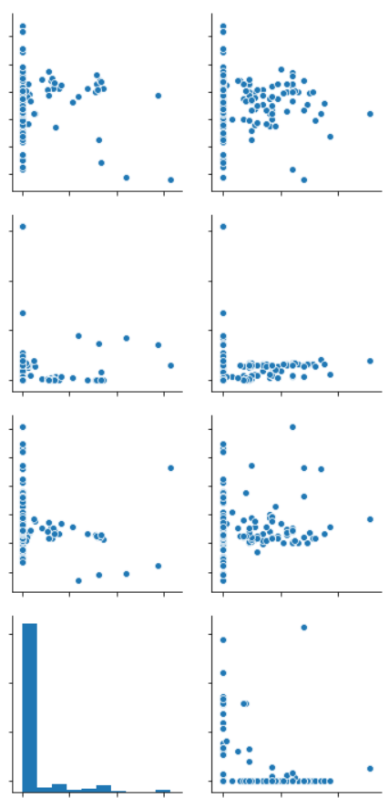

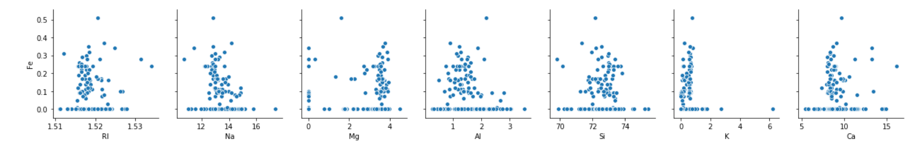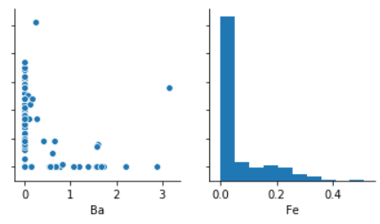

## 3. Using Correlation Matrix

coreleation= X.corr()

plt.figure(figsize=(15,15))

sns.heatmap(coreleation,cbar=True,square=True,annot=True,fmt='.1f',annot_kws={'size': 15},xticklabels=features,yticklabels=features,alpha=0.7,cmap= 'coolwarm')

plt.show()

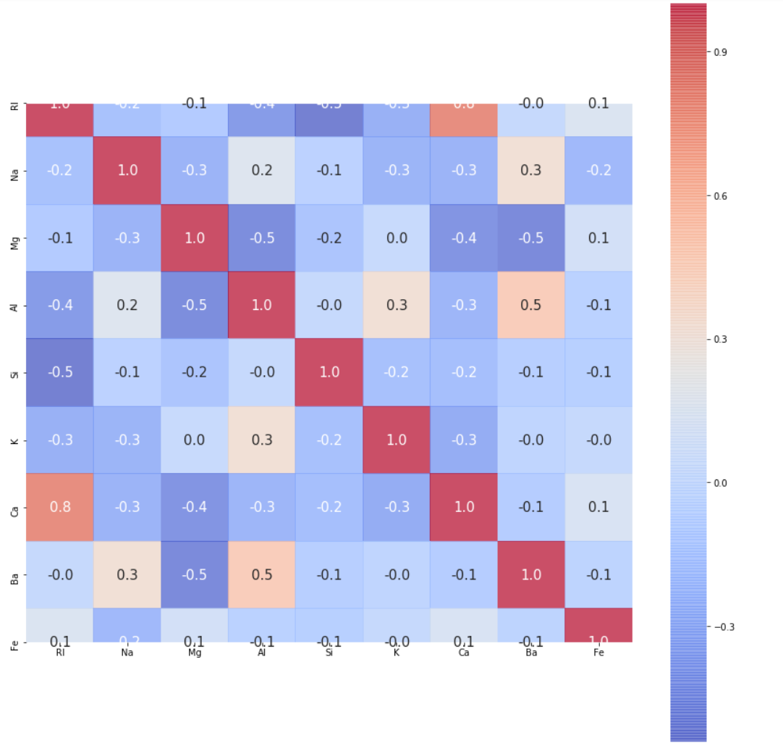

**Outcomes(Analysis)**

1. AI and Ba have an intermediate correlation between each other.
2. RI and Ca have a strong correlation between each other. ( This could be a sign to perform Principal component analysis in order to decorrelate some of the input features. )

# **Outlier Detection**

**Why?**

To Get inference about the no. of outliers present in our dataset.

# Detect observations with more than one outlier

def outlier_hunt(data):

"""

Takes a data frame df of features and returns a list of the indices

corresponding to the observations containing more than 2 outliers.

"""

outlier_indices = []

for col in data.columns.tolist():

Q1 = np.percentile(data[col], 25)

Q3 = np.percentile(data[col],75)

IQR = Q3 - Q1

outlier_step = 1.5 * IQR

outlier_list_col = data[(data[col] < Q1 - outlier_step) | (data[col] > Q3 + outlier_step )].index

outlier_indices.extend(outlier_list_col)

outlier_indices = Counter(outlier_indices)

multiple_outliers = list( k for k, v in outlier_indices.items() if v > 2 )

return multiple_outliers

print('The dataset contains %d observations with more than 2 outliers' %(len(outlier_hunt(data[features]))))

**Outcomes**

1. In our data, There exist around 14 observations with multiple outliers.
2. These could harm the efficiency of our learning algorithms. We'll remove them now.

# **Data Treatment**

**Why?**

To Clean our data and process it so that our Models & Algorithms Train better and make better predictions.

#Information about data in hand

data.info()

<class 'pandas.core.frame.DataFrame'>

RangeIndex: 214 entries, 0 to 213

Data columns (total 10 columns):

RI 214 non-null float64

Na 214 non-null float64

Mg 214 non-null float64

Al 214 non-null float64

Si 214 non-null float64

K 214 non-null float64

Ca 214 non-null float64

Ba 214 non-null float64

Fe 214 non-null float64

glass_type 214 non-null int64

dtypes: float64(9), int64(1)

memory usage: 16.8 KB

**Outcomes**

1. This dataset is clean; there aren't any missing values in it.

## 1. Removing Outliers

**Why?**

The outlier affects both results and assumptions. And are generally not the best representatives of the dataset.

outlier_indices = outlier_hunt(data[features])

df = data.drop(outlier_indices).reset_index(drop=True)

print(data.shape)

**Outcomes**

1. Removing observations with multiple outliers (more than 2) left us with 200 observations to train from

## 2. Normalizing the Data

**Why?**

to change the values of numeric columns in the dataset to a common scale, without distorting differences in the ranges of values (Features also have different Ranges)

## ## normalizing/Scaling the data in [0,1] Range

## 

## from sklearn.preprocessing import MinMaxScaler

## scaler = MinMaxScaler()

## X.head(2)

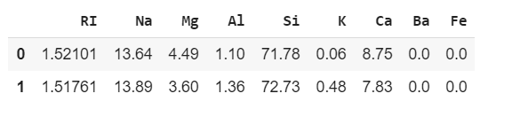

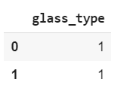

## 3. Scaling The Features

from sklearn import preprocessing

X=preprocessing.scale(X)

# **Visualization of Data after Being Preprocessed**

x2 = X

for i in range(1,9):

sns.distplot(x2[i])

plt.xlabel(features[i])

plt.show()

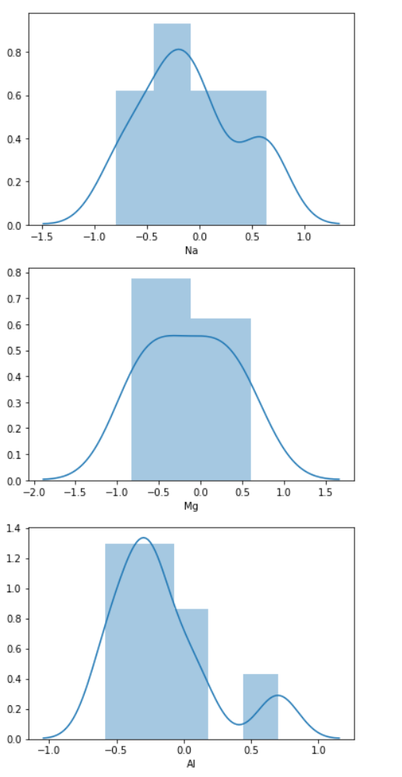

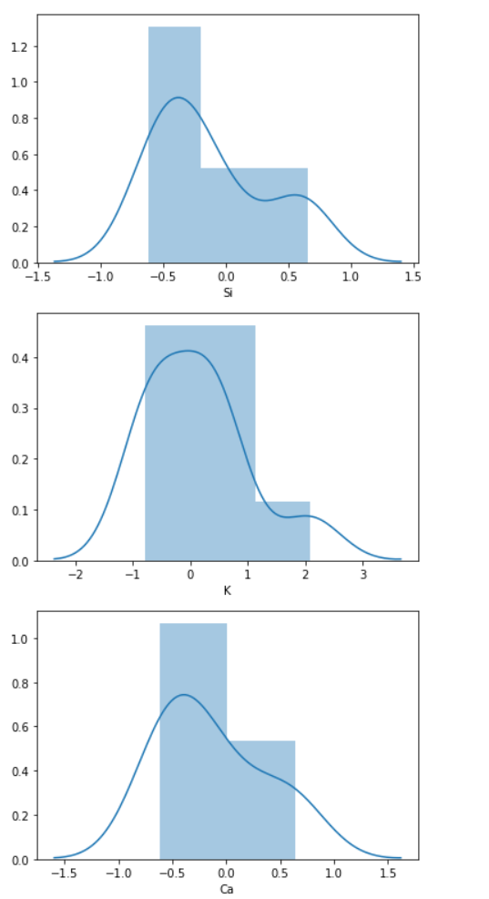

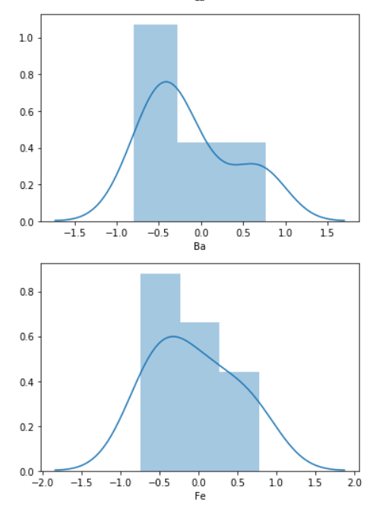

**Outcomes**

According to the Diagrams above, After preprocessing,

1. Skewness is reduced.
2. Data is more normalized.

# **Training set - Test set Split**

**WHY?**

Testing is a way to assess our model performance. To incorporate Cross Validation and to know how our model is performing.

X_train, X_test, y_train, y_test = train_test_split(X, y, test_size=0.25, random_state=0,stratify=y)

y_train = y_train.values.ravel()

y_test = y_test.values.ravel()

print('Shape of X_train = ' + str(X_train.shape))

print('Shape of X_test = ' + str(X_test.shape))

print('Shape of y_train = ' + str(y_train.shape))

print('Shape of y_test = ' + str(y_test.shape))

Shape of X_train = (160, 9)

Shape of X_test = (54, 9)

Shape of y_train = (160,)

Shape of y_test = (54,)

# **Training Different Machine learning Models**

## ***1. K-Nearest Neighbors***

Scores = []

for i in range (2,11):

knn = KNeighborsClassifier(n_neighbors=i)

knn.fit(X_train, y_train)

score = knn.score(X_test,y_test)

Scores.append(score)

print(knn.score(X_train,y_train))

print(Scores)

**Training accuracy** 0.65625

**Testing accuracy** [0.6666666666666666, 0.6296296296296297, 0.6851851851851852, 0.6851851851851852, 0.6851851851851852, 0.7222222222222222, 0.7407407407407407, 0.7222222222222222, 0.7407407407407407]

## **2. Decision Tree**

Scores = []

for i in range(1):

tree = DecisionTreeClassifier(random_state=0)

tree.fit(X_train, y_train)

score = tree.score(X_test,y_test)

Scores.append(score)

print(tree.score(X_train,y_train))

print(Scores)

**Training accuracy** 1.0

**Testing accuracy***:* [0.7037037037037037]

## **3. Logistic Regression**

Scores = []

for i in range(1):

logistic = LogisticRegression(random_state=0, solver='lbfgs',multi_class='multinomial',max_iter=100)

logistic.fit(X_train, y_train)

score = logistic.score(X_test,y_test)

Scores.append(score)

print(logistic.score(X_train,y_train))

print(Scores)

**Training accuracy** 0.65

**Testing accuracy** [0.6296296296296297]

## **4. SVM Classifier (Non-Linear)**

Scores = []

for i in range(1):

svc = SVC(gamma='auto')

svc.fit(X_train, y_train)

score = svc.score(X_test,y_test)

Scores.append(score)

print(svc.score(X_train,y_train))

print(Scores)

**Training accuracy** *:* 0.76875

**Testing accuracy** [0.7407407407407407]

# **Summary**

## Out of all above models:

**Decision Tree**

Decision tree is overfitting with **:->**

*Training accuracy: 1.0*

*Testing accuracy: 0.7037037037037037*

**SVM (Non Linear Kernel)**

SVM (Non Linear Kernel) is giving best result with:

*Training accuracy: 0.76875*

*Testing accuracy: 0.7407407407407407*